**Servlet Architecture**

Servlets are grouped under the Advanced Java tree that is used to create dynamic web applications. Servlets are *robust*, *well scalable,*and are primarily used in developing *server-side applications*. If we go a little back in time, we would be able to witness that before the introduction of servlets, *CGI (Common Gateway Interface)* was used. Among several indigenous tasks that a servlet is capable of doing, dynamically performing client requests and responses are most common. Other tasks that a servlet can do effectively are:

* Can easily manage/control the application flow.
* Suitable to implement business logic.
* Can effectively balance the load on the server side.
* Easily generate dynamic web content.
* Handle HTTP Request and Response
* Also act as an interceptor or filter for a specific group of requests.

**Types of Servlet**

* **Generic Servlets**: These are those servlets that provide functionality for implementing a servlet. It is a generic class from which all the customizable servlets are derived. It is protocol-independent and provides support for HTTP, FTP, and SMTP protocols. The class used is ‘**javax.servlet.Servlet’**and it only has 2 methods – init() to initialize & allocate memory to the servlet and destroy() to deallocate the servlet.
* **HTTP Servlets**: These are protocol dependent servlets, that provides support for HTTP request and response. It is typically used to create web apps. And has two of the most used methods – doGET() and doPOST() each serving their own purpose.

There are three potential ways in which we can employ to create a servlet:

* Implementing Servlet Interface
* Extending Generic Servlet
* Extending HTTP Servlet

**Components of Servlet Architecture**

Servlet Architecture contains the business logic to process all the requests made by client. Below is the high-level architecture diagram of servlet. Let’s see in brief, how does each component add to the working of a servlet.

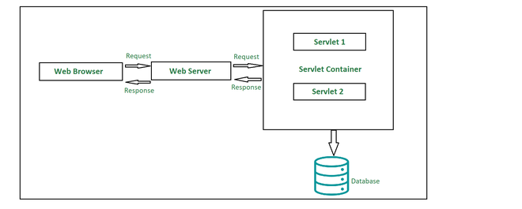

**1. Client**

The client shown in the architecture above is the web browser and it primarily works as a medium that sends out HTTP requests over to the web server and the web server generates a response based on some processing in the servlet and the client further processes the response.

**2. Web Server**

Primary job of a web server is to process the requests and responses that a user sends over time and maintain how a web user would be able to access the files that has been hosted over the server. The server we are talking about here is a software which manages access to a centralized resource or service in a network. There are precisely two types of webservers:

* Static web server
* Dynamic web server

**3. Web Container**

Web container is another typical component in servlet architecture which is responsible for communicating with the servlets. Two prime tasks of a web container are:

* Managing the servlet lifecycle
* URL mapping

Web container sits at the server-side managing and handling all the requests that are coming in either from the servlets or from some JSP pages or potentially any other file system.

**How does a Servlet Request flow?**

Every servlet should override the following 3 methods namely:

1. init(): To initalize/instantiate the servlet container.
2. service(): This method acts like an intermediatory between the HTTP request and the business logic to serve that particular request.
3. destroy(): This method is used to deallocate the memory allocated to the servlet.

These methods are used to process the request from the user.

Following are the steps in which a request flows through a servlet which can be observed in the architecture diagram:

* The client sends over a request.
* The request is accepted by the web server and forwarded to the web container.
* In order to obtain the servlet’s address, the web container traces *web.xml* file corresponding to the request *URL pattern.*
* By the time above process takes place, the servlet should have been instantiated and initialized. The *init()* method is invoked to initialize the servlet.
* By passing *ServletRequest* and *Response object*, *public* *service()* method is called by the container.
* In the next step, the *ServletRequest* and *ServletResponse* objects are type casted to *HttpServletRequest* and *HttpServletResponse* objects by the *public service()* method.
* Now *protected service()* method is called by the *public service()*method.
* The *protected service()* method dispatches the request to the correct handler method based on the type of request.
* When servlet container shuts down, it unloads all the servlets and calls *destroy()* method for each initialized servlet.

**Advantages**

* Prime functionality of a servlet is that they are independent of server configuration, and they are pretty much compatible with any of the web servers.
* Servlets are also protocol-independent supporting *FTP*, *HTTP*, *SMTP*, etc. protocols to the fullest.
* Until destroyed manually, servlets can be retained in the memory helping process several requests over time. Also, once a database connection is established, it can facilitate process several requests for a database in the very same database session.
* Servlets inherit Java’s property of portability and hence are compatible with nearly any web server.
* Servlets are first converted into byte codes and then executed, which helps in increasing the processing time.

**Disadvantages**

* Designing a servlet can be pretty laborious.
* Exceptions need to be handled while designing a servlet since they are not thread safe.
* Developers may need additional skills to program a servlet.

As we already know Servlets are portable (platform/server independent) in nature and hence are a better option if we talk in terms of other scripting languages. They process the requests and responses dynamically. Whenever we are developing a web application where we need to coordinate with different existing protocols, servlets are preferred over other means because of its capability to support various protocols. At last, we can descend to a conclusion that employing a servlet could potentially be most suitable while developing a web application.